EXPERIMENT 7 VM with 1 CPU

Step 1: Create a new virtual Machine

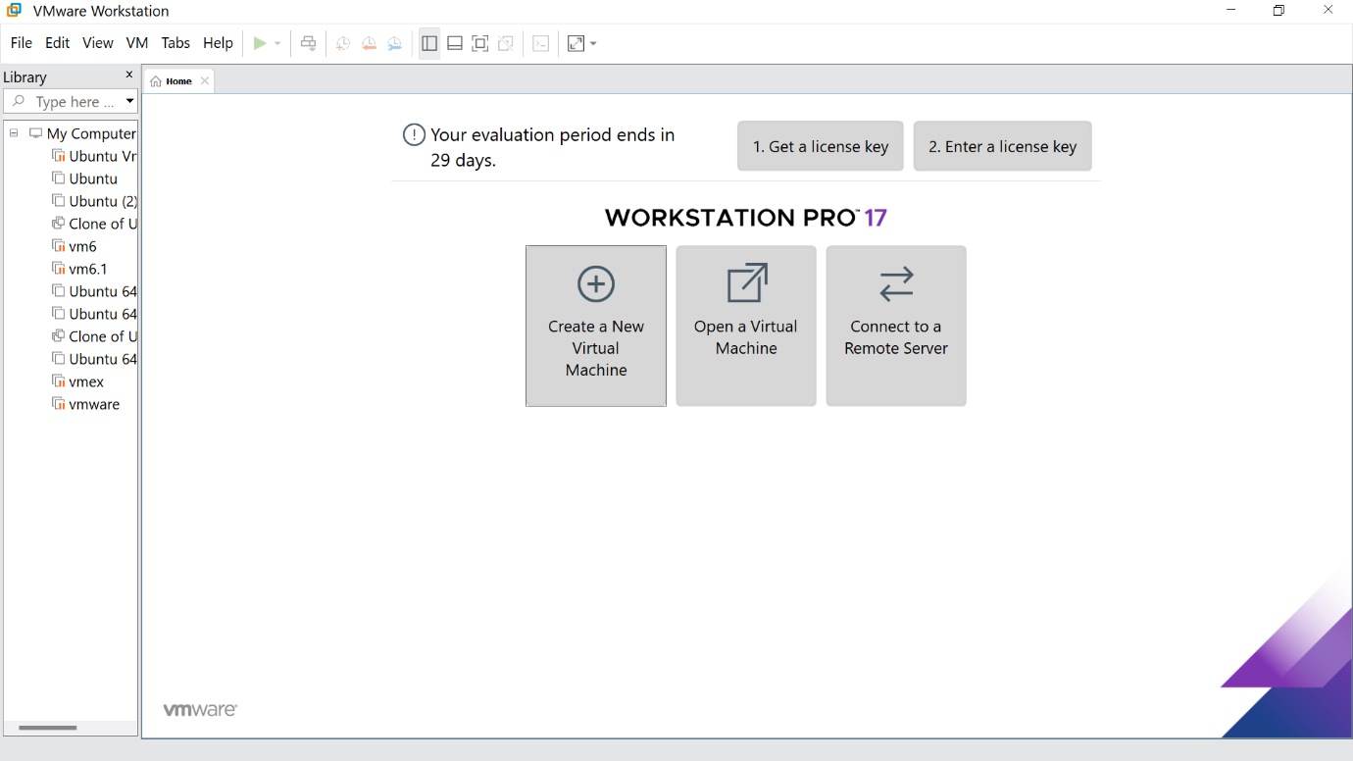

Step 2: Click the Typical option and click Next

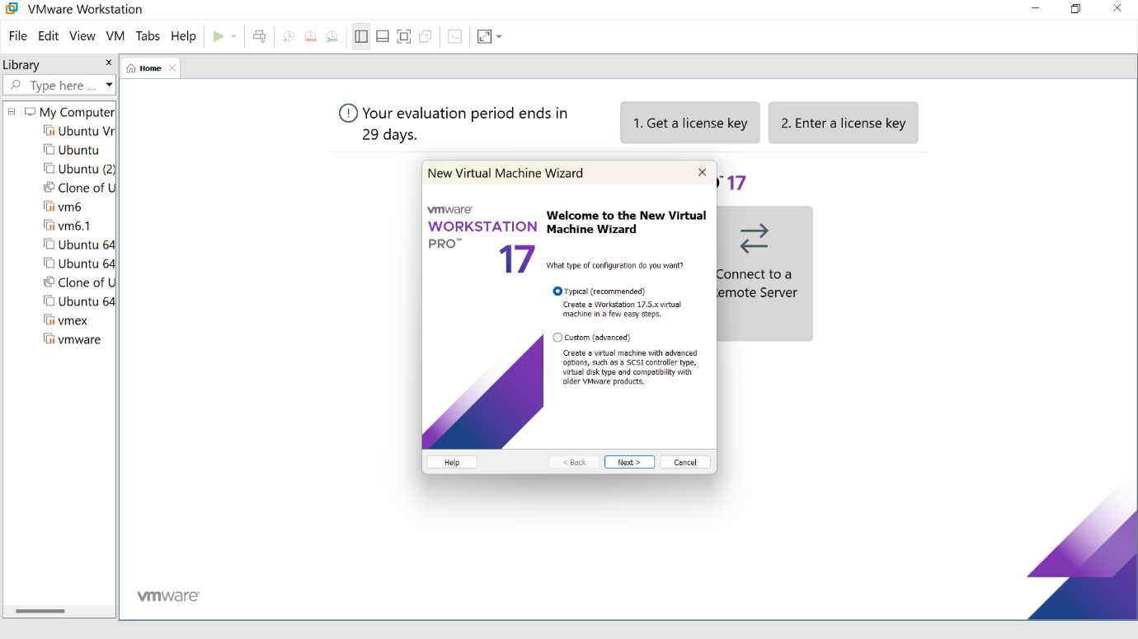

Step 3:Click the install option and proceed to next step

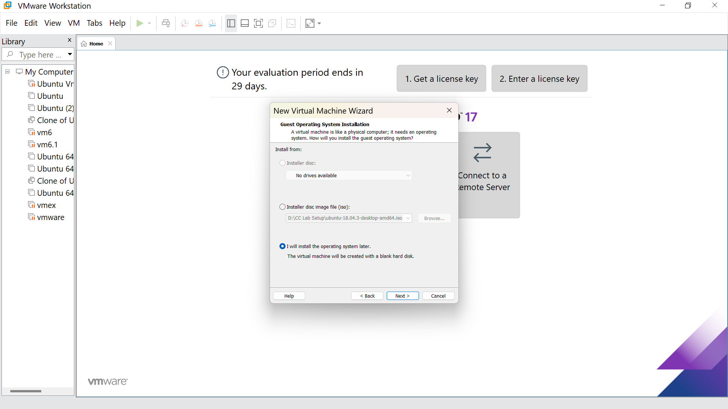

Step 4 :Select Linux option and click Next

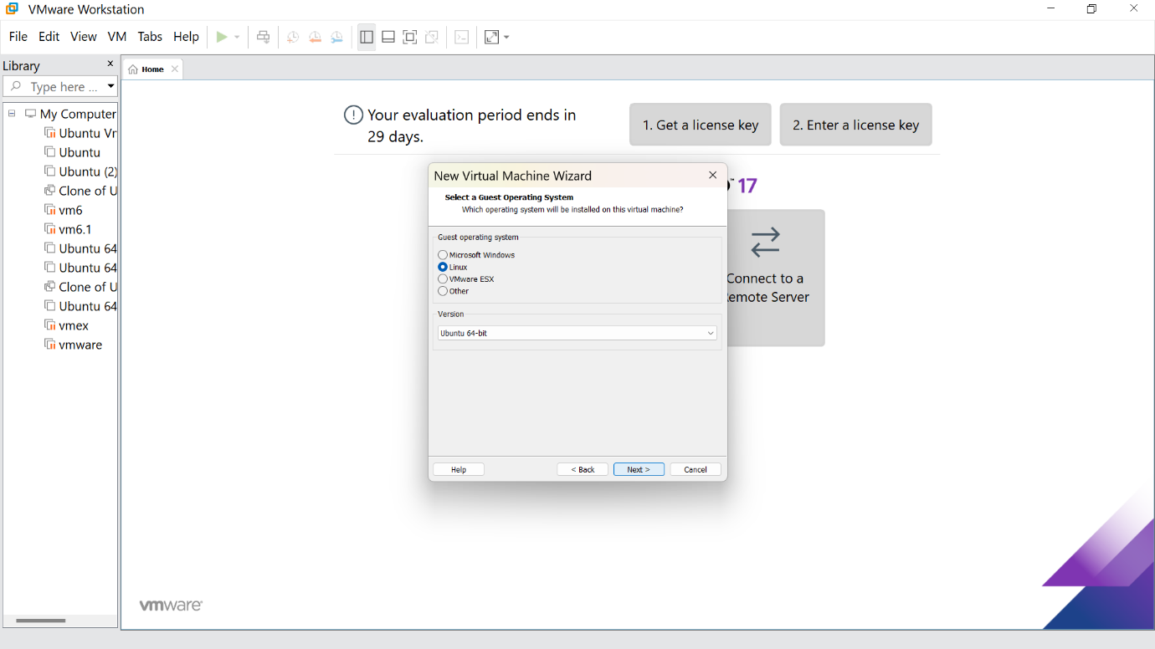

Step 5: Give the name for the virtual machine(optional) and click next

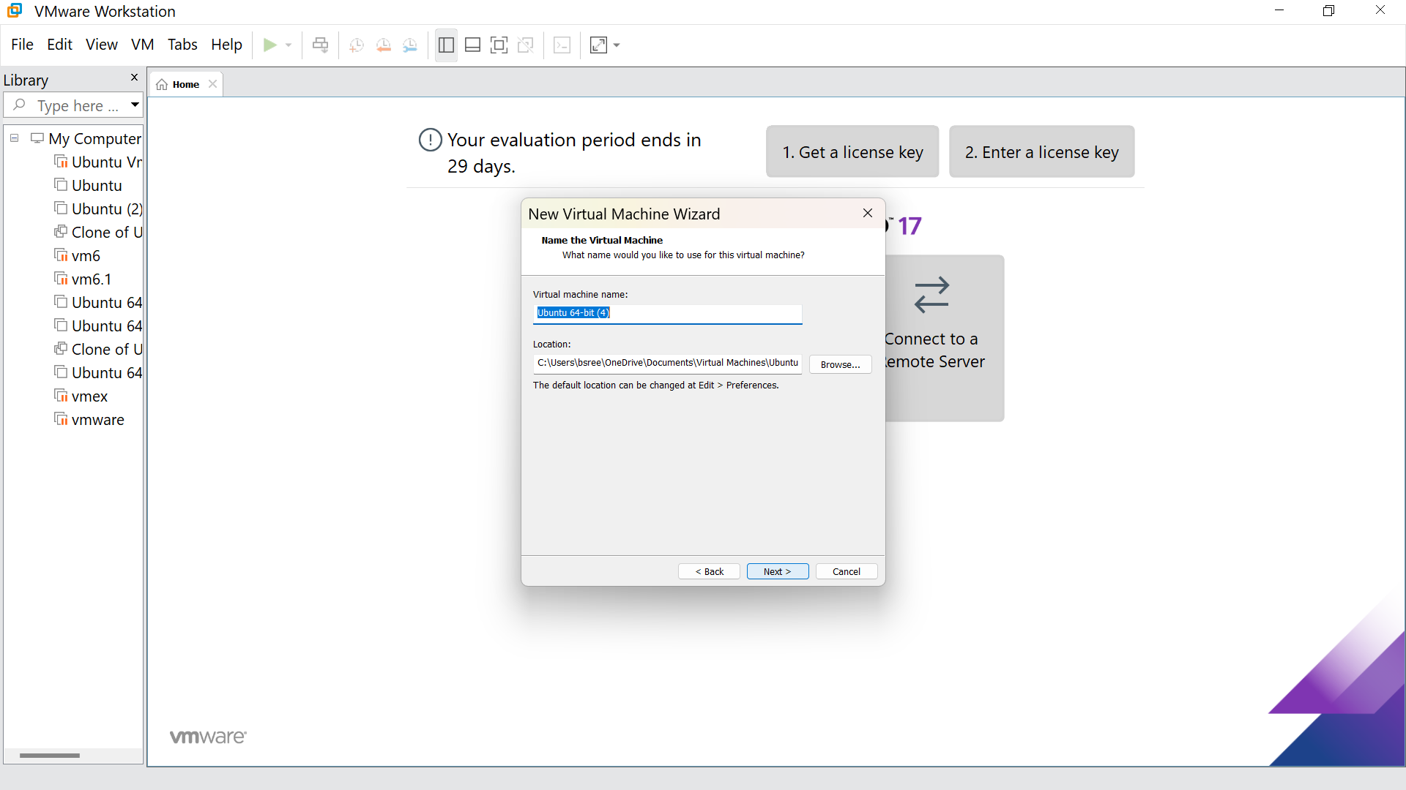

Step 6: Give the maximum disk size as 15.0 GB and click next

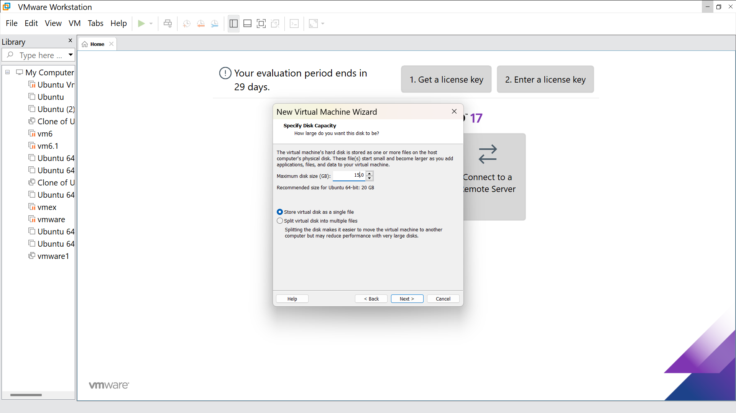

Step7:Our new VM is ready ,click finish

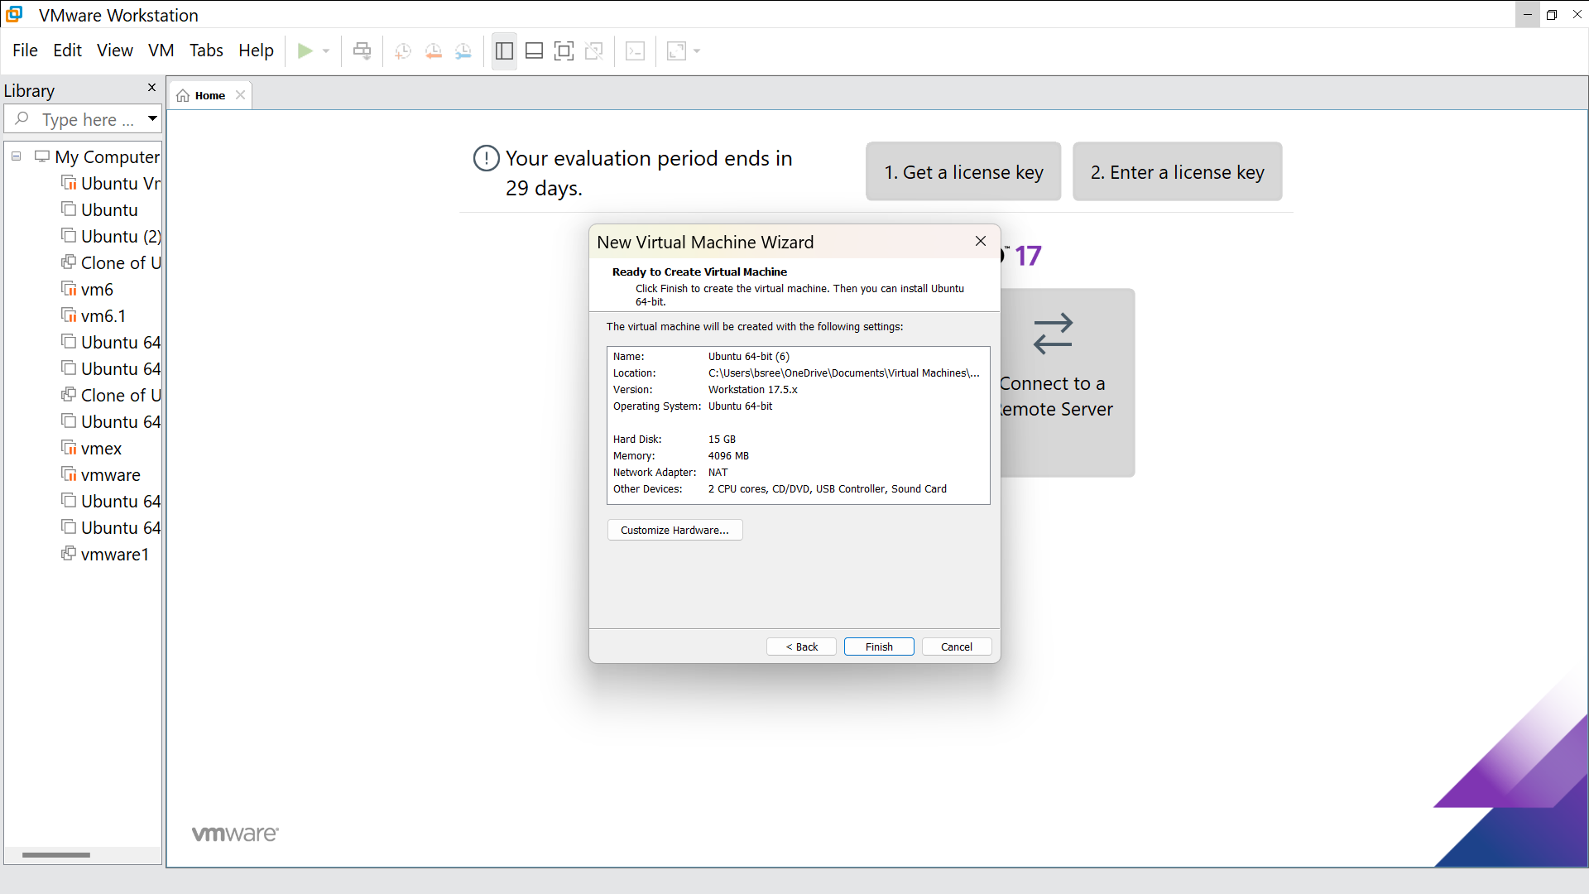

Step : Go to memory and change that to 2 GB

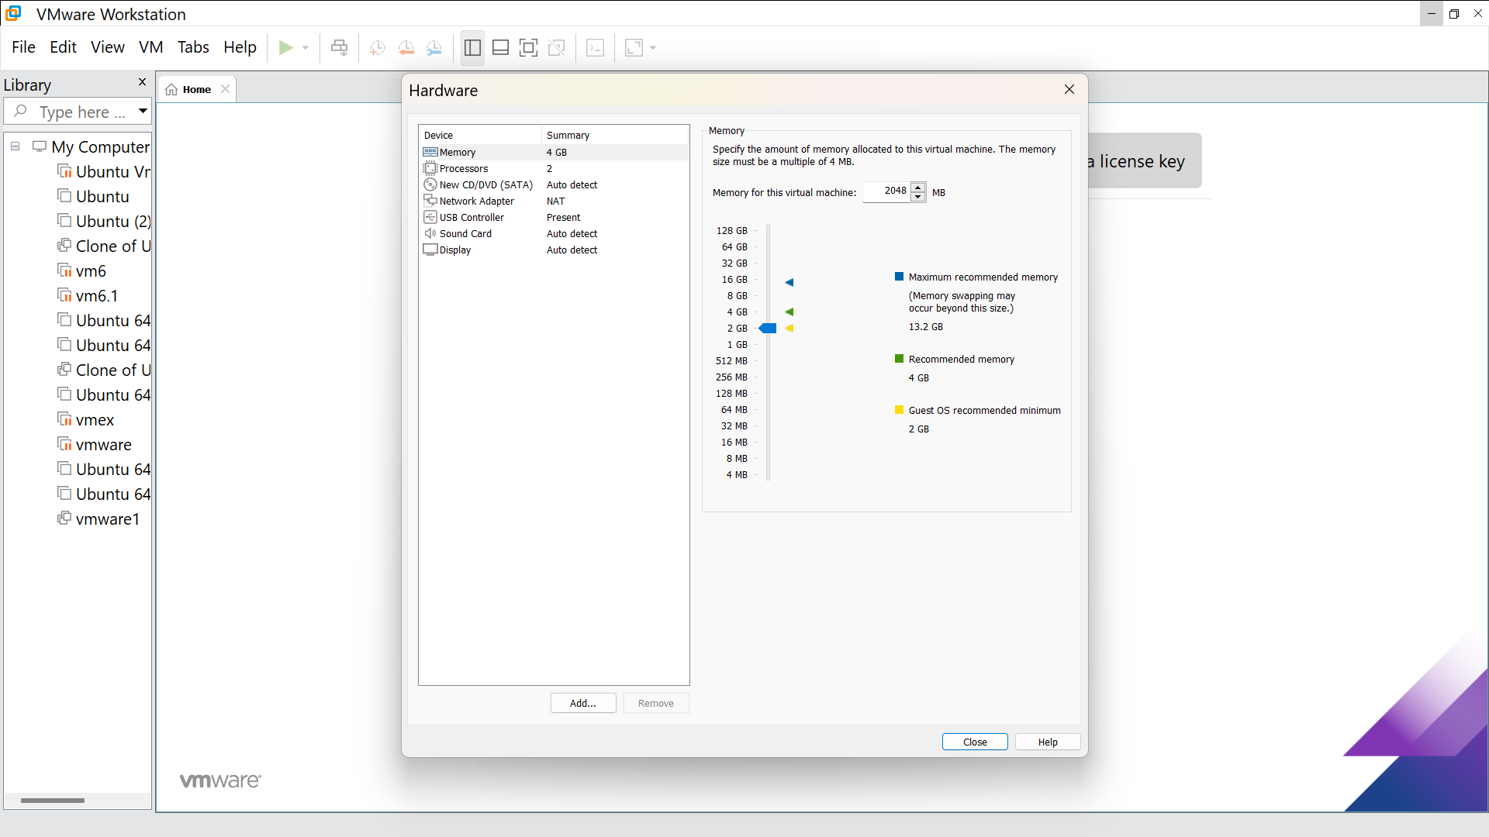

Step 8: This is the creation of VM

